YISU Travel
Dokumentation

Üzeyir Yilmaz
16.10.2024

Bedingungen für den Source Code:
Angular CLI: 18.2.6 (npm install -g @angular/cli@18.2.6)
Node: 20.17.0 (https://nodejs.org/download/release/v20.17.0/)
Package Manager: npm 10.8.2
OS: win32 x64

Package Version
------------------------------------------------------
@angular-devkit/architect 0.1802.6 (cli-only)
@angular-devkit/core 18.2.6 (cli-only)
@angular-devkit/schematics 18.2.6 (cli-only)
@schematics/angular 18.2.6 (cli-only)

Installationen:
ng add @angular/material
- Version: @angular/material@18.2.6
- npm install @angular/material@18.2.6

ng add @angular/cdk
- @angular/cdk": "^18.2.6
- npm install @angular/cdk@18.2.6

npm install angular-bootstrap-md
- Version: "bootstrap": "^5.3.3",
- npm install bootstrap@5.3.3

npm i ngx-mat-timepicker
- Version: ngx-mat-timepicker@18.0.0
- npm install ngx-mat-timepicker@18.0.0

npm install core-js whatwg-fetch

ng generate config browserslist
das einfügen: (Safari fix)
last 2 Chrome versions
last 1 Firefox version
last 2 Edge major versions
last 2 Safari major versions
Safari >= 15
last 2 iOS major versions
last 2 Android major versions
Firefox ESR

npm i swiper
"swiper": "^11.1.15",
npm install swiper@11.1.15

Bei Neuinstallation:
Nachdem man den ganzen Projekt kopiert hat auf den neuen Rechner, löscht man den nodes Ordner, danach:
rm -rf node_modules package-lock.json

Anschließend npm i

SSR und SSG aktivieren:
ng add @angular/ssr (Wichtig für SEO, da HTML Dateien statisch geladen werden)
- ng build (alles im Ordner dist/browser hochladen)
- => FALLS EINE index.csr.html generiert wurde nach ng build im dist/browser Ordner, BENNENE ES UM IN index.html und lösche die vorherige index.html.
  - Falls beide (index.csr.html, index.html) generiert werden, dann nur den index.html deployen und den anderen löschen
- outputHashing auf none und optimization auf true stellen in der angular.json

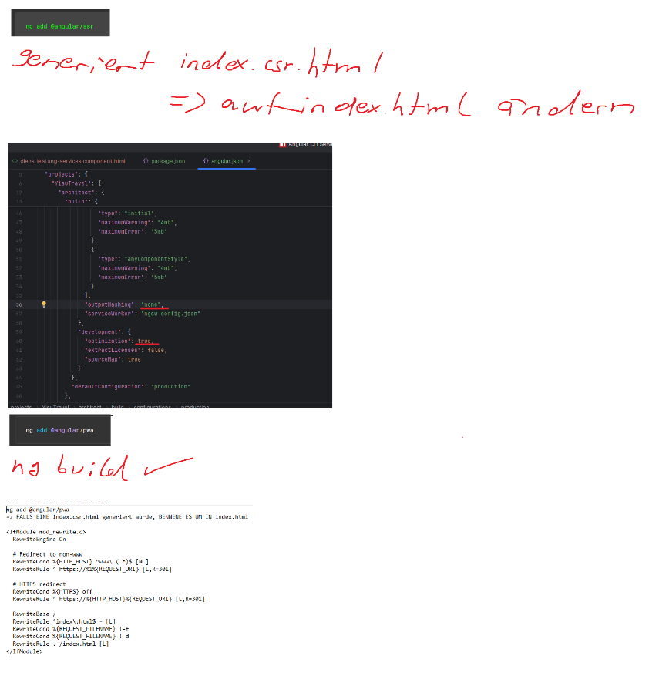

Cache Problem verhindern:
KEIN: ng add @angular/pwa 18.2.10 Version verwenden!!!
- Sobald SSR aktiviert ist, werden die Sachen schon statisch geladen. Wir müssen nur noch den .htaccess so schreiben, dass er niemals cache speichert, damit der Browser immer aktuell ist. Cache ist sehr gefährlich. Wie machen wir das? Siehe .htaccess Einstellung.

Weitere Versionen (Bootstrap usw. in der package.json)
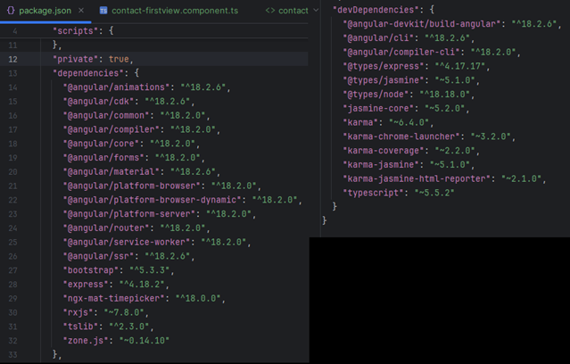
Font awesome runterladen (im lokalen Ordner wegen dsgvo und im /public/fontawesome/ packen):
- Version fontawesome-free-6.0.0-beta3-web
Herunterladen:
https://use.fontawesome.com/releases/v6.0.0-beta3/fontawesome-free-6.0.0-beta3-web.zip

Wichtige Anmeldedaten:

IONOS: Webhosting
https://login.ionos.de/?shoplogin=enabled
264653739
YiSu2016Travel

IONOS: VPS
923432449
Stayhappy1#

FTP FileZilla:
-sftp://u75950685@home511037246.1and1-data.host
u75950685
Y1sU_Tr4v3l.!79-X

Database:
Y1sU_Tr4v3l.Datab4se_87!_.&

Livechat Integration:
Login: https://1148.3cx.cloud/#/login?next=%2Foffice

Anmeldename & Passwort
info@yisu-travel.de
Y1sU_Tr4v3l.!79-X

Fonts:
1) Herunterladen z.B.
https://fontawesome.com/download
https://fonts.google.com/selection

2) in /public/fonts google fonts reintun und von fontawesome auch in ein public/fontawesome ordner und all.min.css reintun
3) in styles.css alles rein (chatgpt + dir /b alles laden und dann adden lassen)

/* Roboto Font Faces */
@font-face {
font-family: 'Roboto';
font-weight: 100; /* Thin */
font-style: normal;
src: url('/fonts/Roboto-Thin.ttf') format('truetype'),
url('/fonts/Roboto-ThinItalic.ttf') format('truetype');
}

@font-face {
font-family: 'Roboto';
font-weight: 300; /* Light */
font-style: normal;
src: url('/fonts/Roboto-Light.ttf') format('truetype'),
url('/fonts/Roboto-LightItalic.ttf') format('truetype');
}

@font-face {
font-family: 'Roboto';
font-weight: 400; /* Regular */
font-style: normal;
src: url('/fonts/Roboto-Regular.ttf') format('truetype'),
url('/fonts/Roboto-Italic.ttf') format('truetype');
}

@font-face {
font-family: 'Roboto';
font-weight: 500; /* Medium */
font-style: normal;
src: url('/fonts/Roboto-Medium.ttf') format('truetype'),
url('/fonts/Roboto-MediumItalic.ttf') format('truetype');
}

@font-face {
font-family: 'Roboto';
font-weight: 700; /* Bold */
font-style: normal;
src: url('/fonts/Roboto-Bold.ttf') format('truetype'),
url('/fonts/Roboto-BoldItalic.ttf') format('truetype');
}

@font-face {
font-family: 'Roboto';
font-weight: 900; /* Black */
font-style: normal;
src: url('/fonts/Roboto-Black.ttf') format('truetype'),
url('/fonts/Roboto-BlackItalic.ttf') format('truetype');
}

4) in angular.json fontawesome laden:
"styles": [
"@angular/material/prebuilt-themes/azure-blue.css",
"public/fontawesome/fontawesome-free-6.0.0-beta3-web/css/all.min.css",
"src/styles.css"
],

=> Copy path from content root

Server Einstellungen und SEO Optimization

.htaccess (erstellen im Root Ordner der Domain)
Aktuellste Version, kein http und kein www (kein doppelter Content wegen SEO)
<IfModule mod_rewrite.c>
RewriteEngine On

# Umleitung von /startseite/ auf die Hauptseite /
RewriteCond %{REQUEST_URI} ^/startseite/?$
RewriteRule ^ / [R=301,L]

# Redirect to non-www
RewriteCond %{HTTP_HOST} ^www\.(.*)$ [NC]
RewriteRule ^ https://%1%{REQUEST_URI} [L,R=301]

# HTTPS redirect
RewriteCond %{HTTPS} off
RewriteRule ^ https://%{HTTP_HOST}%{REQUEST_URI} [L,R=301]

RewriteBase /

# Ensure index.html is not rewritten
RewriteRule ^index\.html$ - [L]

# Handle Angular routes (SSG and SSR)
RewriteCond %{REQUEST_FILENAME} !-f
RewriteCond %{REQUEST_FILENAME} !-d
RewriteRule . /index.html [L]
</IfModule>

<IfModule mod_headers.c>
# Enable necessary headers for PWA and SSR
Header set Cache-Control "no-store, no-cache, must-revalidate"
Header set Pragma "no-cache"
Header set Expires 0
</IfModule>

- Erstelle in der google search console eine sitemap.xml, eine google google080d84130527cbc7.html und eine robots.txt Datei für den Crawler.

Inhalt:
- sitemap.xml:

<?xml version="1.0" encoding="UTF-8"?>
<urlset
xmlns="http://www.sitemaps.org/schemas/sitemap/0.9"
xmlns:xsi="http://www.w3.org/2001/XMLSchema-instance"
xsi:schemaLocation="http://www.sitemaps.org/schemas/sitemap/0.9
http://www.sitemaps.org/schemas/sitemap/0.9/sitemap.xsd">
<!-- created with Free Online Sitemap Generator www.xml-sitemaps.com -->

<url>
<loc>https://yisu-travel.de/</loc>
<lastmod>2024-10-05T06:03:48+00:00</lastmod>
</url>
</urlset>

#bearbeitet
<?xml version="1.0" encoding="UTF-8"?>
<urlset
xmlns="http://www.sitemaps.org/schemas/sitemap/0.9"
xmlns:xsi="http://www.w3.org/2001/XMLSchema-instance"
xsi:schemaLocation="http://www.sitemaps.org/schemas/sitemap/0.9
http://www.sitemaps.org/schemas/sitemap/0.9/sitemap.xsd">
<!-- created with Free Online Sitemap Generator www.xml-sitemaps.com -->

<url>
<loc>https://yisu-travel.de/startseite</loc>
<priority>1.0</priority>
<lastmod>2024-10-05T06:03:48+00:00</lastmod>
</url>
<url>
<loc>https://yisu-travel.de/ueber-uns</loc>
<priority>0.8</priority>
</url>
<url>
<loc>https://yisu-travel.de/dienstleistung</loc>
<priority>0.8</priority>
</url>
<url>
<loc>https://yisu-travel.de/kontakt</loc>
<priority>0.7</priority>
</url>
<url>
<loc>https://yisu-travel.de/impressum</loc>
<priority>0.5</priority>
</url>
<url>
<loc>https://yisu-travel.de/datenschutzerklaerung</loc>
<priority>0.5</priority>
</url>

</urlset>

//AKTUELL
<urlset xmlns="http://www.sitemaps.org/schemas/sitemap/0.9"
xsi:schemaLocation="http://www.sitemaps.org/schemas/sitemap/0.9
http://www.sitemaps.org/schemas/sitemap/0.9/sitemap.xsd"
xmlns:xsi="http://www.w3.org/2001/XMLSchema-instance">

<url>
<loc>https://yisu-travel.de/startseite</loc>
<priority>1.0</priority>
<lastmod>2024-10-05T06:03:48+00:00</lastmod>
<changefreq>daily</changefreq>
</url>

<url>
<loc>https://yisu-travel.de/ueber-uns</loc>
<priority>0.8</priority>
<lastmod>2024-10-05T06:03:48+00:00</lastmod>
<changefreq>monthly</changefreq>
</url>

<url>
<loc>https://yisu-travel.de/dienstleistung</loc>
<priority>0.8</priority>
<lastmod>2024-10-05T06:03:48+00:00</lastmod>
<changefreq>monthly</changefreq>
</url>

<url>
<loc>https://yisu-travel.de/kontakt</loc>
<priority>0.7</priority>
<lastmod>2024-10-05T06:03:48+00:00</lastmod>
<changefreq>monthly</changefreq>
</url>

<url>
<loc>https://yisu-travel.de/impressum</loc>
<priority>0.5</priority>
<lastmod>2024-10-05T06:03:48+00:00</lastmod>
<changefreq>yearly</changefreq>
</url>

<url>
<loc>https://yisu-travel.de/datenschutzerklaerung</loc>
<priority>0.5</priority>
<lastmod>2024-10-05T06:03:48+00:00</lastmod>
<changefreq>yearly</changefreq>
</url>

</urlset>

- google080d84130527cbc7.html
google-site-verification: google080d84130527cbc7.html

- robots.txt
# Erlaubt allen Bots den Zugang zur gesamten Website
User-agent: *
Allow: /

# Blockiere administrative und irrelevante Bereiche
Disallow: /admin/
Disallow: /wp-admin/
Disallow: /cgi-bin/
Disallow: /login
Disallow: /search

# Gebe die Sitemap der Website an, damit Bots die Struktur verstehen
Sitemap: https://yisu-travel.de/sitemap.xml

Einen /backend/ Ordner im Root Folder der Domain erstellten und folgende beiden php Dateien einfügen für:
- send_mail.php
<?php
// Check if POST request is made
if ($_SERVER["REQUEST_METHOD"] == "POST") {

// Get the posted form data
$name = htmlspecialchars($_POST['name'], ENT_QUOTES, 'UTF-8');
$email = htmlspecialchars($_POST['email'], ENT_QUOTES, 'UTF-8');
$subject = htmlspecialchars($_POST['subject'], ENT_QUOTES, 'UTF-8');
$message = nl2br(htmlspecialchars($_POST['message'], ENT_QUOTES, 'UTF-8'));

// Prepare the email for you
$to = "medi.edi@gmx.de"; // Your IONOS email to receive the contact messages
$email_subject = "Kontaktformular von YISU Travel: $subject";
$email_body = "
<!DOCTYPE html>
<html lang='de'>
<head>
<meta charset='UTF-8'>
<meta name='viewport' content='width=device-width, initial-scale=1.0'>
<style>
body {
font-family: Arial, sans-serif;
margin: 0;
padding: 20px;
background-color: #f7f7f7;
}
.container {
max-width: 600px;
margin: auto;
background: #ffffff;
padding: 30px;
border-radius: 8px;
box-shadow: 0 2px 4px rgba(0, 0, 0, 0.1);
}
h2 {
color: #333333;
margin-bottom: 20px;
font-size: 24px;
text-align: left;
}
.info {
font-size: 16px;
color: #333333;
margin-bottom: 10px;
}
.message {
font-size: 16px;
line-height: 1.5;
color: #333333;
margin-top: 15px;
background-color: #ffffff; /* Hellerer Hintergrund für die Nachricht */
border-radius: 4px;
}
.footer {
margin-top: 20px;
font-size: 12px;
color: #777777;
border-top: 1px solid #e0e0e0;
padding-top: 10px;
text-align: center;
}
</style>
</head>
<body>
<div class='container'>
<h2>Neue Nachricht von www.yisu-travel.de</h2>
<div class='info'><strong>Name:</strong> $name</div>
<div class='info'><strong>E-Mail:</strong> $email</div>
<div class='info'><strong>Betreff:</strong> $subject</div>
<div class='message'>
<strong>Nachricht:</strong><br>
$message
</div>
</div>
</body>
</html>
";

// Set the email headers for the main email
$headers = "From: info@yisu-travel.de\r\n";
$headers .= "Reply-To: $email\r\n";
$headers .= "Content-Type: text/html; charset=UTF-8\r\n";

// Send the email to you
if (mail($to, $email_subject, $email_body, $headers)) {
// Prepare confirmation email for the user
$user_email_subject = "Ihr Kontaktformular an YISU Travel";
$user_email_body = "
<!DOCTYPE html>
<html lang='de'>
<head>
<meta charset='UTF-8'>
<meta name='viewport' content='width=device-width, initial-scale=1.0'>
<style>
body {
font-family: Arial, sans-serif;
margin: 0;
padding: 20px;
background-color: #f7f7f7;
}
.container {
max-width: 600px;
margin: auto;
background: #ffffff;
padding: 30px;
border-radius: 8px;
box-shadow: 0 2px 4px rgba(0, 0, 0, 0.1);
}
h2 {
color: #333333;
margin-bottom: 20px;
font-size: 24px;
text-align: left;
}
.info {
font-size: 16px;
color: #333333;
margin-bottom: 10px;
}
.message {
font-size: 16px;
line-height: 1.5;
color: #333333;
margin-top: 15px;
background-color: #ffffff; /* Hellerer Hintergrund für die Nachricht */
border-radius: 4px;
}
.footer {
margin-top: 20px;
font-size: 12px;
color: #777777;
border-top: 1px solid #e0e0e0;
padding-top: 10px;
text-align: center;
}
</style>
</head>
<body>
<div class='container'>
<h2>Vielen Dank für Ihr Kontaktformular an YISU Travel!</h2>
<div class='info'><strong>Name:</strong> $name</div>
<div class='info'><strong>E-Mail:</strong> $email</div>
<div class='info'><strong>Betreff:</strong> $subject</div>
<div class='message'>
<strong>Ihre Nachricht:</strong><br>
$message
</div>
<div class='footer'>
<p>Wir werden uns so schnell wie möglich bei Ihnen melden.</p>
</div>
</div>
</body>
</html>
";

// Set the email headers for the confirmation email
$user_headers = "From: info@yisu-travel.de\r\n";
$user_headers .= "Reply-To: info@yisu-travel.de\r\n";
$user_headers .= "Content-Type: text/html; charset=UTF-8\r\n";

// Send the confirmation email to the user
mail($email, $user_email_subject, $user_email_body, $user_headers);

echo json_encode(["status" => "success", "message" => "E-Mail wurde erfolgreich gesendet!"]);
} else {
echo json_encode(["status" => "error", "message" => "Fehler beim Senden der E-Mail."]);
}
} else {
// Return error for non-POST requests
echo json_encode(["status" => "error", "message" => "Ungültige Anfrage."]);
}
?>

- send_termin.php

<?php
// Error reporting for debugging
error_reporting(E_ALL);
ini_set('display_errors', 1);

// Check if POST request is made
if ($_SERVER["REQUEST_METHOD"] == "POST") {

// Get the JSON posted data
$data = json_decode(file_get_contents('php://input'), true);

// Check if data is received
if ($data) {
// Sanitize and prepare the form data
$name = htmlspecialchars($data['name'], ENT_QUOTES, 'UTF-8');
$email = htmlspecialchars($data['email'], ENT_QUOTES, 'UTF-8');

// Format the date
$date = htmlspecialchars($data['date'], ENT_QUOTES, 'UTF-8');
$date = date('d.m.Y', strtotime($date)); // Nur den Tag um 1 erhöhen

$time = htmlspecialchars($data['time'], ENT_QUOTES, 'UTF-8');
$topic = htmlspecialchars($data['topic'], ENT_QUOTES, 'UTF-8');
$message = nl2br(htmlspecialchars($data['message'], ENT_QUOTES, 'UTF-8'));

// Prepare the email for you
$to = "medi.edi@gmx.de"; // Your IONOS email to receive the appointment messages
$email_subject = "Terminvereinbarung YISU Travel";
$email_body = "
<!DOCTYPE html>
<html lang='de'>
<head>
<meta charset='UTF-8'>
<meta name='viewport' content='width=device-width, initial-scale=1.0'>
<style>
body {
font-family: Arial, sans-serif;
margin: 0;
padding: 20px;
background-color: #f7f7f7;
}
.container {
max-width: 600px;
margin: auto;
background: #ffffff;
padding: 30px;
border-radius: 8px;
box-shadow: 0 2px 4px rgba(0, 0, 0, 0.1);
}
h2 {
color: #333333;
margin-bottom: 20px;
font-size: 24px;
text-align: left;
}
.info {
font-size: 16px;
color: #333333;
margin-bottom: 10px;
}
.message {
font-size: 16px;
line-height: 1.5;
color: #333333;
margin-top: 15px;
background-color: #ffffff; /* Hellerer Hintergrund für die Nachricht */
border-radius: 4px;
}
.footer {
margin-top: 20px;
font-size: 12px;
color: #777777;
border-top: 1px solid #e0e0e0;
padding-top: 10px;
text-align: center;
}
</style>
</head>
<body>
<div class='container'>
<h2>Neue Terminvereinbarung von www.yisu-travel.de</h2>
<div class='info'><strong>Name:</strong> $name</div>
<div class='info'><strong>E-Mail:</strong> $email</div>
<div class='info'><strong>Datum:</strong> $date</div>
<div class='info'><strong>Uhrzeit:</strong> $time</div>
<div class='info'><strong>Thema:</strong> $topic</div>
<div class='message'>
<strong>Nachricht:</strong><br>
$message
</div>
</div>
</body>
</html>
";

// Set the email headers for the main email
$headers = "From: info@yisu-travel.de\r\n";
$headers .= "Reply-To: $email\r\n";
$headers .= "Content-Type: text/html; charset=UTF-8\r\n";

// Send the email to you
if (mail($to, $email_subject, $email_body, $headers)) {
// Prepare confirmation email for the user
$user_email_subject = "Ihre Terminvereinbarung an YISU Travel";
$user_email_body = "
<!DOCTYPE html>
<html lang='de'>
<head>
<meta charset='UTF-8'>
<meta name='viewport' content='width=device-width, initial-scale=1.0'>
<style>
body {
font-family: Arial, sans-serif;
margin: 0;
padding: 20px;
background-color: #f7f7f7;
}
.container {
max-width: 600px;
margin: auto;
background: #ffffff;
padding: 30px;
border-radius: 8px;
box-shadow: 0 2px 4px rgba(0, 0, 0, 0.1);
}
h2 {
color: #333333;
margin-bottom: 20px;
font-size: 24px;
text-align: left;
}
.info {
font-size: 16px;
color: #333333;
margin-bottom: 10px;
}
.message {
font-size: 16px;
line-height: 1.5;
color: #333333;
margin-top: 15px;
background-color: #ffffff; /* Hellerer Hintergrund für die Nachricht */
border-radius: 4px;
}
.footer {
margin-top: 20px;
font-size: 12px;
color: #777777;
border-top: 1px solid #e0e0e0;
padding-top: 10px;
text-align: center;
}
</style>
</head>
<body>
<div class='container'>
<h2>Vielen Dank für Ihre Terminvereinbarung an YISU Travel!</h2>
<div class='info'><strong>Name:</strong> $name</div>
<div class='info'><strong>E-Mail:</strong> $email</div>
<div class='info'><strong>Datum:</strong> $date</div>
<div class='info'><strong>Uhrzeit:</strong> $time</div>
<div class='info'><strong>Thema:</strong> $topic</div>
<div class='message'>
<strong>Ihre Nachricht:</strong><br>
$message
</div>
<div class='footer'>
<p>Wir werden uns so schnell wie möglich bei Ihnen melden.</p>
</div>
</div>
</body>
</html>
";

// Set the email headers for the confirmation email
$user_headers = "From: info@yisu-travel.de\r\n";
$user_headers .= "Reply-To: info@yisu-travel.de\r\n";
$user_headers .= "Content-Type: text/html; charset=UTF-8\r\n";

// Send the confirmation email to the user
mail($email, $user_email_subject, $user_email_body, $user_headers);

echo json_encode(["status" => "success", "message" => "E-Mail wurde erfolgreich gesendet!"]);
} else {
echo json_encode(["status" => "error", "message" => "Fehler beim Senden der E-Mail."]);
}
} else {
echo json_encode(["status" => "error", "message" => "Fehlende Daten."]);
}
} else {
// Return error for non-POST requests
echo json_encode(["status" => "error", "message" => "Ungültige Anfrage."]);
}
?>

- api.php

<?php
include '../../backend/config.php';

$link = new mysqli($host_name, $user_name, $password, $database);
header('Content-Type: application/json');

$method = $_SERVER['REQUEST_METHOD'];
$data = json_decode(file_get_contents("php://input"), true);

switch ($method) {
case 'GET':
handleGetRequest($link);
break;
case 'POST':
handlePostRequest($data, $link);
break;
case 'PUT':
echo json_encode(['message' => 'PUT-Anfrage empfangen', 'data' => $data]);
break;
case 'DELETE':
echo json_encode(['message' => 'DELETE-Anfrage empfangen', 'data' => $data]);
break;
default:
echo json_encode(['message' => 'Ungültige Anfrage-Methode']);
break;
}

function handleGetRequest($link) {
$date = $_GET['date'] ?? date('Y-m-d'); // Default to today's date

// Force the date to UTC to avoid time zone issues
$stmt = $link->prepare("SELECT time FROM appointments WHERE DATE(date) = ?");
$stmt->bind_param("s", $date);
$stmt->execute();
$result = $stmt->get_result();

$appointments = [];
while ($row = $result->fetch_assoc()) {
$appointments[] = $row['time']; // Retrieve only times
}
$stmt->close();

echo json_encode([
'success' => true,
'message' => 'Appointments retrieved.',
'appointments' => $appointments
]);
}

function handlePostRequest($data, $link) {
$name = $data['name'] ?? '';
$email = $data['email'] ?? '';
$date = $data['date'] ?? '';
$time = $data['time'] ?? '';

if (empty($name) || empty($email) || empty($date) || empty($time)) {
echo json_encode(['success' => false, 'message' => 'Alle Felder müssen ausgefüllt sein.']);
return;
}

// Berechnung der Zeitspanne
$datetime = new DateTime("$date $time");
$startTime = $datetime->modify('-29 minutes')->format('Y-m-d H:i:s');
$endTime = (clone $datetime)->modify('+29 minutes')->format('Y-m-d H:i:s');

// Überprüfen, ob ein Termin in den nächsten 30 Minuten existiert
$stmt = $link->prepare("SELECT COUNT(*) FROM appointments WHERE date = ? AND (time BETWEEN ? AND ?)");
$stmt->bind_param("sss", $date, $startTime, $endTime);
$stmt->execute();
$stmt->bind_result($count);
$stmt->fetch();
$stmt->close();

if ($count > 0) {
handleExistingAppointments($date, $startTime, $endTime, $link);
} else {
insertNewAppointment($name, $email, $date, $time, $link);
}
}

function handleExistingAppointments($date, $startTime, $endTime, $link) {
$stmt = $link->prepare("SELECT date, time FROM appointments WHERE date = ? AND (time BETWEEN ? AND ?)");
$stmt->bind_param("sss", $date, $startTime, $endTime);
$stmt->execute();
$result = $stmt->get_result();

$appointments = [];
while ($row = $result->fetch_assoc()) {
$appointments[] = [
'date' => $row['date'],
'time' => $row['time']
];
}
$stmt->close();

echo json_encode([
'success' => false,
'message' => 'Ein Termin kann nicht gebucht werden, da innerhalb der nächsten 30 Minuten bereits ein Termin besteht.',
'appointments' => $appointments
]);
}

function insertNewAppointment($name, $email, $date, $time, $link) {
$stmt = $link->prepare("INSERT INTO appointments (name, email, date, time) VALUES (?, ?, ?, ?)");
$stmt->bind_param("ssss", $name, $email, $date, $time);

if ($stmt->execute()) {
echo json_encode(['success' => true, 'message' => 'Termin erfolgreich gespeichert.']);
} else {
echo json_encode(['success' => false, 'message' => 'Fehler beim Speichern des Termins: ' . $stmt->error]);
}
$stmt->close();
}

$link->close();
?>

Dabei ist zu beachten, dass der „include '../../backend/config.php';“ Bereich die config files enthält zur Anmeldung (Bereitgestellt von IONOS), die sollten außerhalb der öffentlichen Domain liegen. (z.B. test/angular prod files, dann test/backend/config.php)

- config.php
<?php
$host_name = 'db5016367545.hosting-data.io';
$database = 'dbs13306900';
$user_name = 'dbu1673899';
$password = 'Y1sU_Tr4v3l.Datab4se_87!_.&';
?>

Allgemeine Informationen:
https://mdbootstrap.com/

Favicons richtig anzeigen lassen:
https://www.softicons.com/icon-tools/icon-converter

runterladen und für jedes Format im index.html verweisen:
<link rel="icon" type="image/png" sizes="16x16" href="public/favicon/favicon1 (2).png">
<link rel="icon" type="image/png" sizes="24x24" href="public/favicon/favicon1 (3).png">
<link rel="icon" type="image/png" sizes="32x32" href="public/favicon/favicon1 (5).png">
<link rel="icon" type="image/png" sizes="48x48" href="public/favicon/favicon1 (7).png">
<link rel="icon" type="image/png" sizes="128x128" href="public/favicon/favicon1 (9).png">
<link rel="icon" type="image/png" sizes="256x256" href="public/favicon/favicon1 (1).png">

Wichtig: canonical definieren, um die wichtigste Seite anzugeben:
<link rel="canonical" href="https://yisu-travel.de/startseite" />

- /backend/version.php
<?php
header('Content-Type: application/json');
echo json_encode(['version' => '1.0.0']);

Richtig animieren mit Angular:

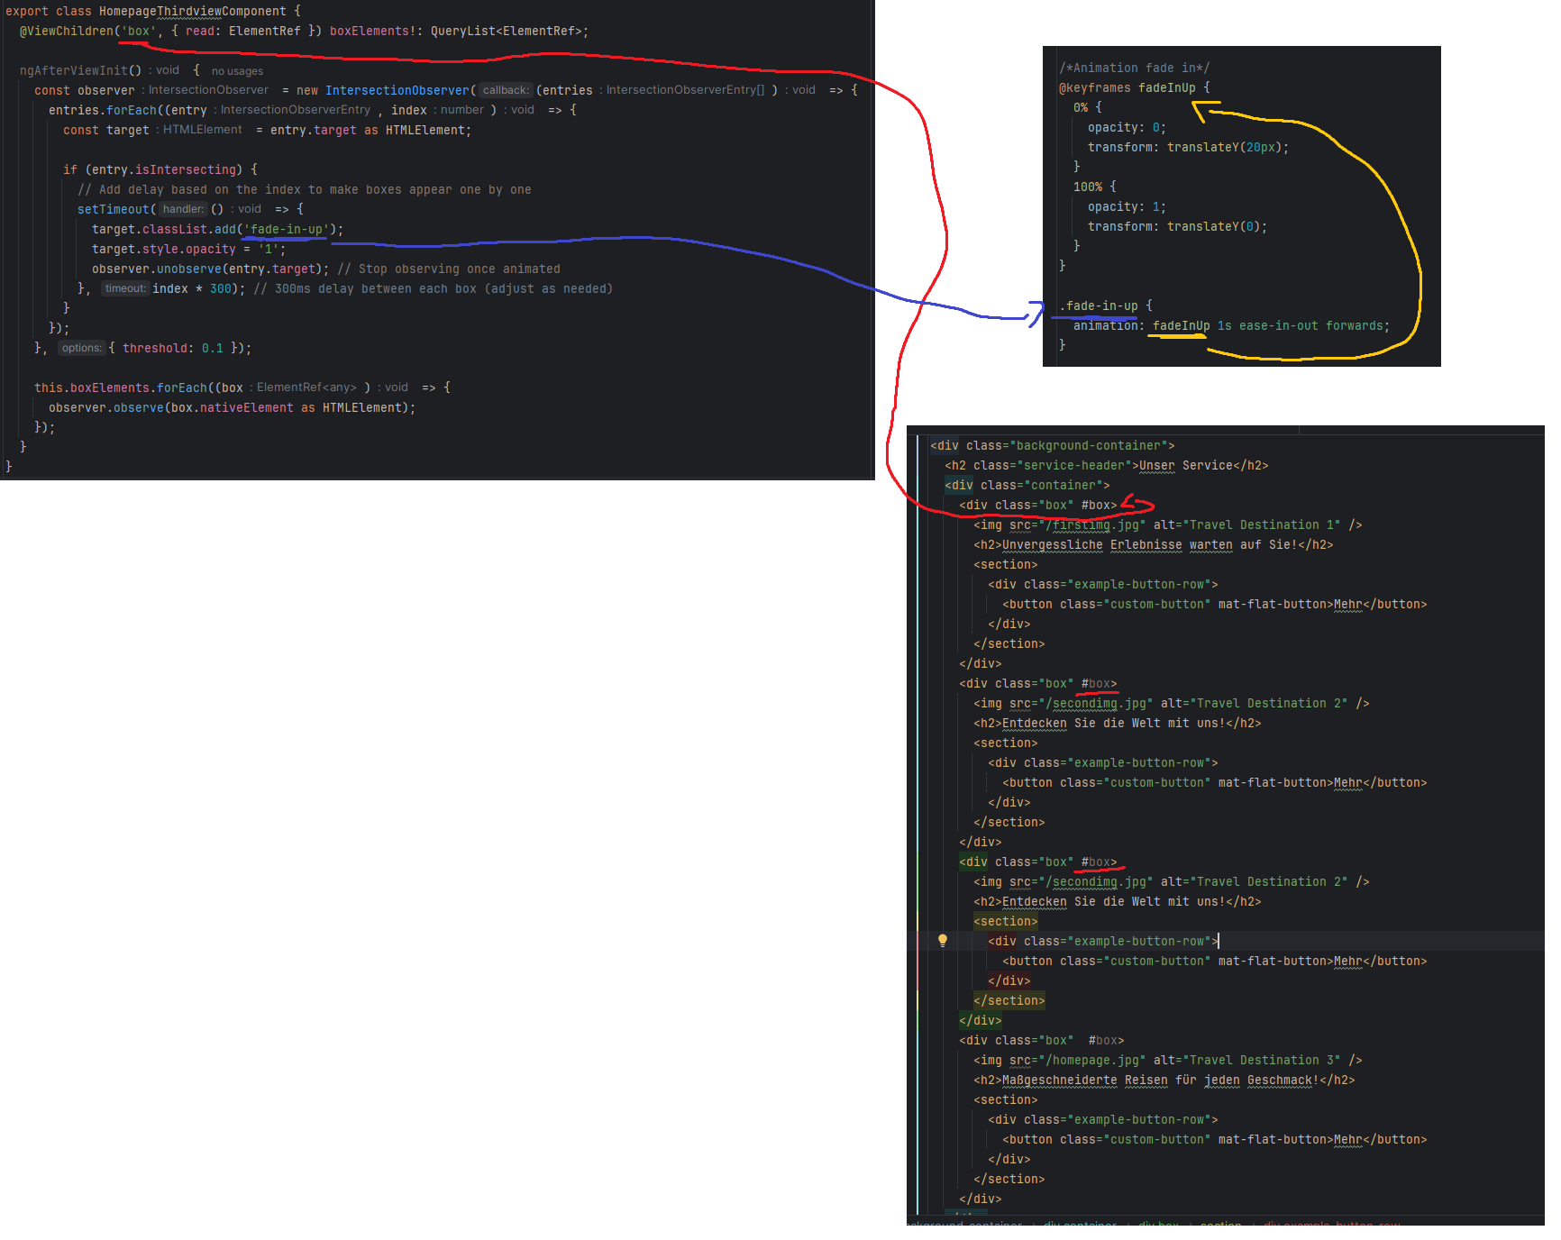

Cache Problem lösen

Die Datei ngsw-config.json bearbeiten:
Das hinzufügen:
"dataGroups": [
{
"name": "cache",
"urls": ["/backend/version"],
"cacheConfig": {
"strategy": "freshness",
"maxAge": "0s",
"timeout": "0s",
"maxSize": 0
}
}
]

Ganzer Code:
{
"$schema": "./node_modules/@angular/service-worker/config/schema.json",
"index": "/index.html",
"assetGroups": [
{
"name": "app",
"installMode": "prefetch",
"resources": {
"files": [
"/favicon.ico",
"/index.html",
"/manifest.webmanifest",
"/*.css",
"/*.js"
]
}
},
{
"name": "assets",
"installMode": "lazy",
"updateMode": "prefetch",
"resources": {
"files": [
"/**/*.(svg|cur|jpg|jpeg|png|apng|webp|avif|gif|otf|ttf|woff|woff2)"
]
}
}
],
"dataGroups": [
{
"name": "cache",
"urls": ["/backend/version"],
"cacheConfig": {
"strategy": "freshness",
"maxAge": "0s",
"timeout": "0s",
"maxSize": 0
}
}
]
}

Danach Service erstellen um von dort manuell die Versionsnummer jedes Mal zu ändern, nachdem man einen Deploy gemacht hat:
export class VersionControlService {
private localVersion = '1.0.0'; // Example local version, adjust as necessary
constructor(private http: HttpClient) {}
checkVersion(): Observable<{ version: string }> {
return this.http.get<{ version: string }>('/backend/version.php');
}
isVersionMismatch(remoteVersion: string): boolean {
return remoteVersion !== this.localVersion;
}
}

Anschließend im App Component ts aufrufen:
ngOnInit() {
this.checkVersion();
// Register the service worker
if ('serviceWorker' in navigator) {
navigator.serviceWorker.register('ngsw-worker.js').then(registration => {
console.log('Service Worker registered with scope:', registration.scope);
}).catch(error => {
console.error('Service Worker registration failed:', error);
});
}
}

checkVersion() {
this.versionService.checkVersion().subscribe(
(response) => {
if (this.versionService.isVersionMismatch(response.version)) {
console.log('Version mismatch detected. Refreshing page...');
this.updateServiceWorker();
}
},
(error) => {
console.error('Failed to fetch version:', error);
}
);
}
updateServiceWorker() {
if ('serviceWorker' in navigator) {
navigator.serviceWorker.getRegistrations().then(registrations => {
for (let registration of registrations) {
registration.unregister().then(() => {
console.log('Service Worker unregistered. Reloading page...');
location.reload(); // Reload the page after unregistering the service worker
});
}
}).catch(error => {
console.error('Failed to unregister service workers:', error);
});
}
}

Project im Netzwerk erreichbar machen:
ng serve --host 0.0.0.0

